****Tarlac State University

**COLLEGE OF COMPUTER STUDIES**

Case Study

in

Integrative Programming Technology 2

Submitted By:

**Salviejo, Leo Maximus**

**Sanchez, Bryle**

**Tagata, Gerry, Jr.**

Submitted To:

**Pineda, Kwinno**

Date: March 11, 2023

Table of Contents

A. Definition 2

B. Case Analysis (Git and GitHub Workflow) 3

B.1 Documentation 3

C. References 4

# Definition

Create a static website upload the documentation and files in your GitHub repository each members will upload their webpage online using Git to GiHub development create a documentation your case study.

**Requirements:**

* Each member in your group will need to upload **a webpage**
* Create a **Pull Request** for each member in Github with comments.
* Create an **Issue** for each member in Github and comment.
* Create a **Milestone** for the group in Github.
* Create a branch for each member and merge it with your maste/main branch in Github.

**Define and describe how you use of each command with screenshot in your case study.**

* **Git clone** - is primarily used to point to an existing repo and make a clone or copy of that repo at in a new directory, at another location(1).

* **Git Pull** - is used to fetch and download content from a remote repository and immediately update the local repository to match that content (2).

* **Git Push** - is used to upload local repository content to a remote repository(3).

* **Git Fetch** - downloads commits, files, and refs from a remote repository into your local repo (4).

Fetching is what you do when you want to see what everybody else has been working on .

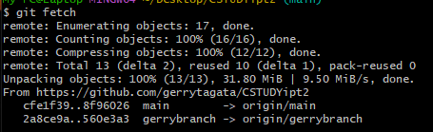

* **Git Merge** - will combine multiple sequences of commits into one unified history (5).

* **Issue** - let you track your work on GitHub, where development happens. When you mention an issue in another issue or pull request, the issue's timeline reflects the cross-reference so that you can keep track of related work (6).

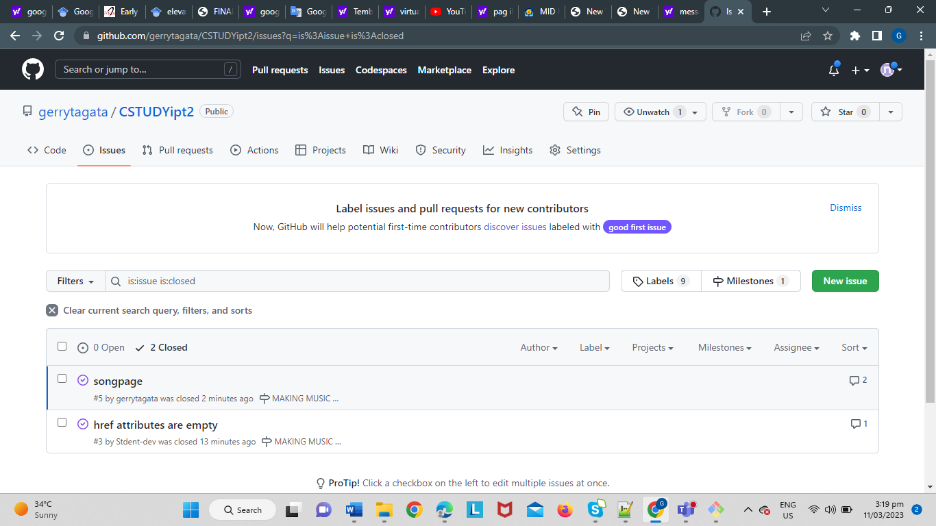

* **Pull Request** - also referred to as a merge request – is an event that takes place in software development when a contributor/developer is ready to begin the process of merging new code changes with the main project repository (7).

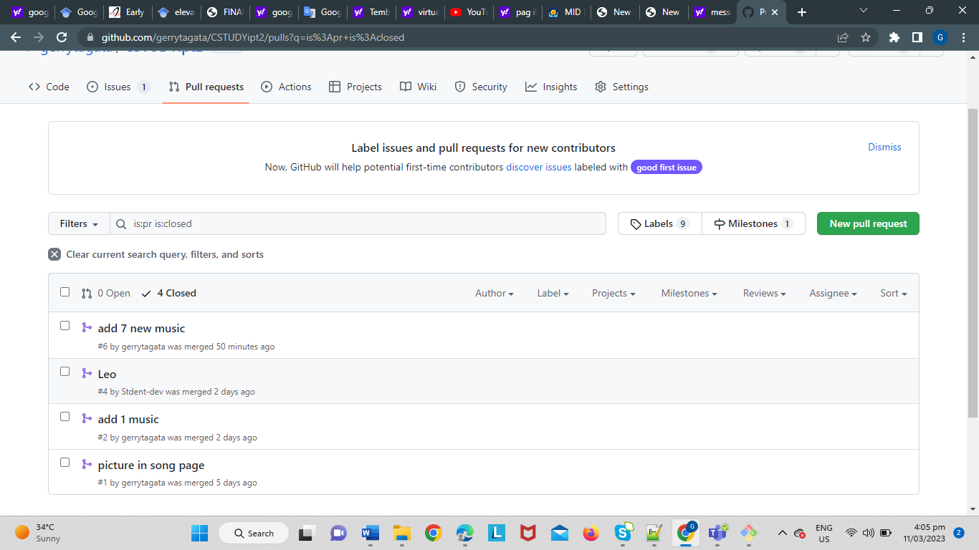

* **Milestone** - You can use milestones to track progress on groups of issues or pull requests in a repository (8).

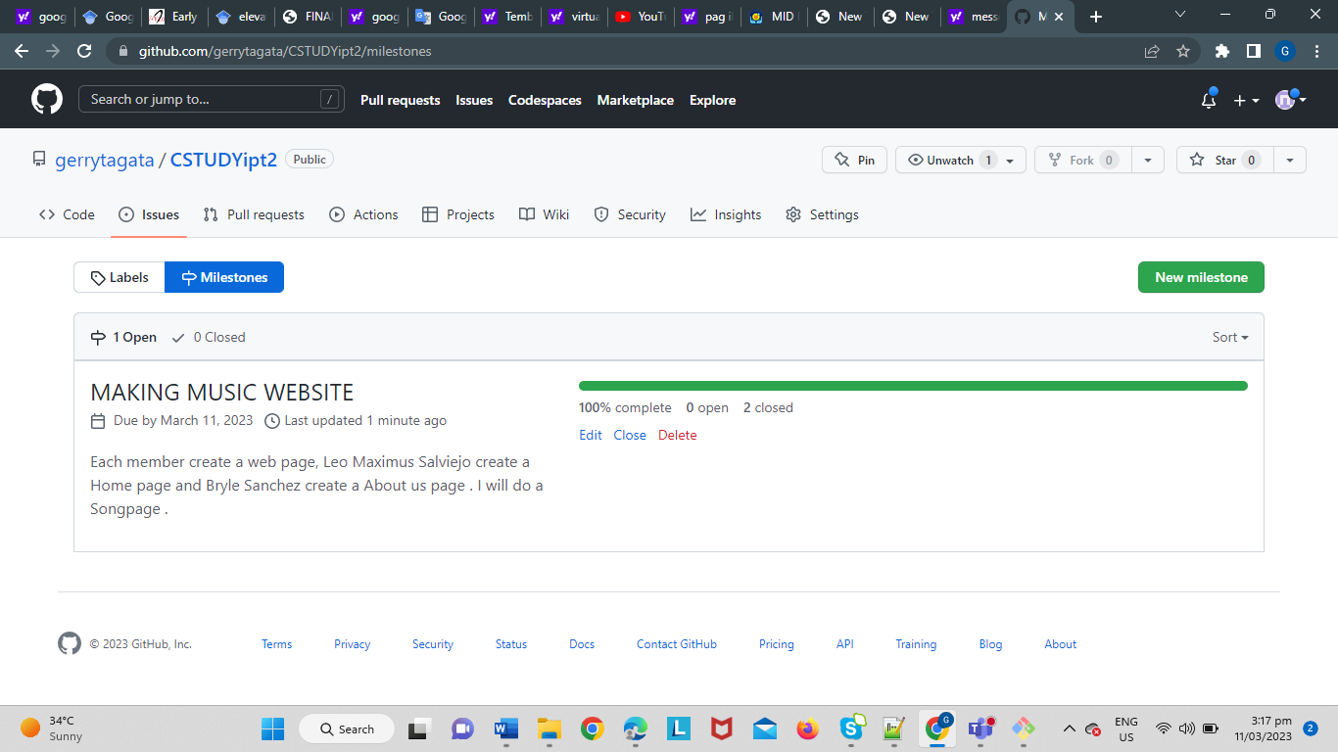

* **Branch** - branches are effectively a pointer to a snapshot of your changes. When you want to add a new feature or fix a bug—no matter how big or how small—you spawn a new branch to encapsulate your changes (9).

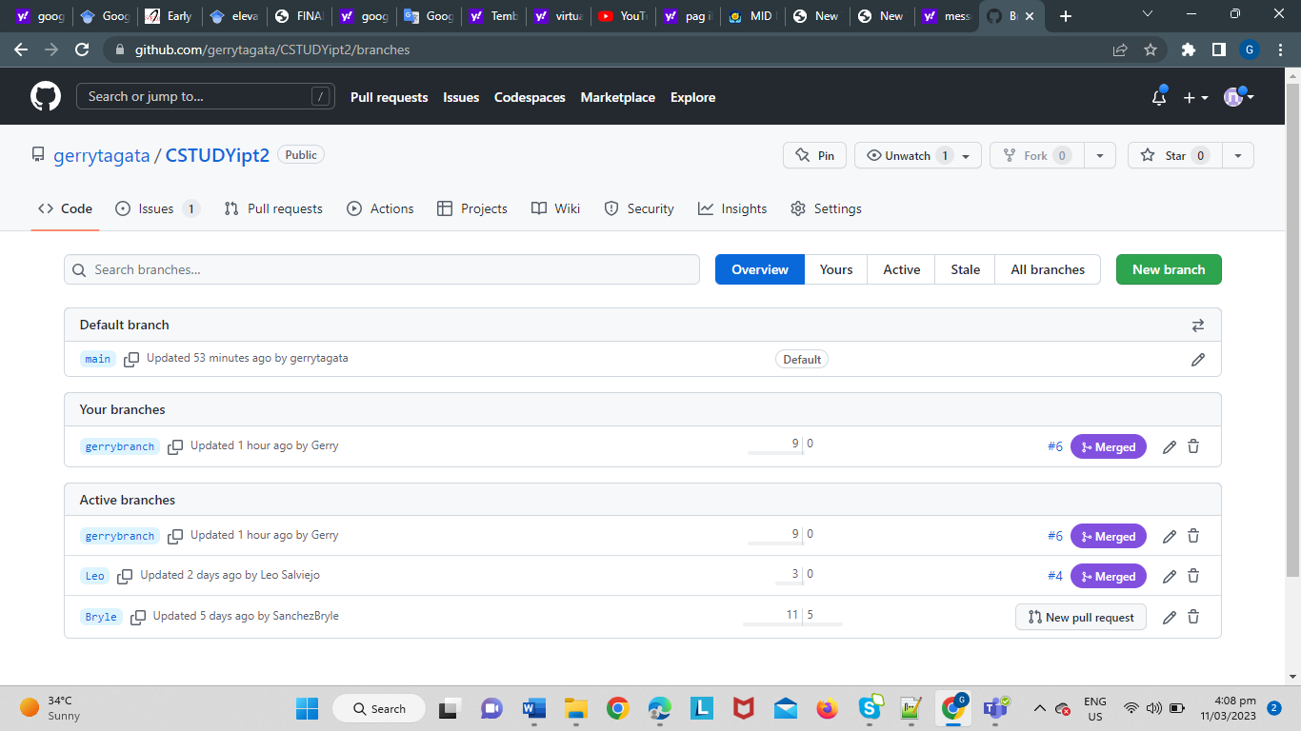

**Note:**

* **List the contributions of your group members**
* **Only one copy of the case study for each group must be submitted. You may group to maximum of 4 members and minimum of 2 members for each group.**
* **Each members needs to contribute to the case study and upload his/her webpage.**
* **Add me as contributor for your project in *kwino.newme@gmail.com***

**Contributions of Group Members:**

1. Salviejo, Leo Maximus

* index.html, style.css, Leo branch, issue, and pull request

1. Sanchez, Bryle

* aboutus.html, aboutus.css, Bryle branch, and issue

1. Tagata, Gerry, Jr.

* Repository in github, songpage.html, songpage.css, and issue

# Case Analysis (Git and GitHub Workflow)

## Documentation

Our team decided to make a static music website. It comprises of three webpages that each member have contributed. The website is incrementally develop using gitbash and github. We use the required git commands shown above. We created our main repository in Github named CSTUDYipt2. Then we each cloned the repo into our own computers. We use the concept of branching to isolate the code from the main branch when we are in the process of structuring and styling. We use git merge to combine different branches in our local repository when we are satisfied with our work. We use git push to upload and update our remote repository so others can see a team members commits. We use git fetch to check some updates and to not accidentally fetch and merge the files from github. We use git push if we would want to update our own local repository so we can integrate them in our work. We use pull requests to merge branches in github. We use issues to take note of some bugs and be reminded of the work we still need to do. We use milestone to set the general objective of our team and set specific issues around it.

# References

Use IEEE format.

[1] <https://www.atlassian.com/git/tutorials/setting-up-a-repository/git-clone#:~:text=git%20clone%20is%20primarily%20used,copies%20an%20existing%20Git%20repository.>

[2] [https://www.atlassian.com/git/tutorials/syncing/git-pull#:~:text=The%20git%20pull%20command%20is,Git%2Dbased%20collaboration%20work%20flows.\](https://www.atlassian.com/git/tutorials/syncing/git-pull#:~:text=The%20git%20pull%20command%20is,Git%2Dbased%20collaboration%20work%20flows./)

[3] <https://www.atlassian.com/git/tutorials/syncing/git-push#:~:text=The%20git%20push%20command%20is,exports%20commits%20to%20remote%20branches.>

[4] <https://www.atlassian.com/git/tutorials/syncing/git-fetch#:~:text=In%20review%2C%20git%20fetch%20is,of%20collaborative%20git%20work%20flows.>

[5] <https://www.atlassian.com/git/tutorials/using-branches/git-merge>

[6] <https://docs.github.com/en/issues/tracking-your-work-with-issues/about-issues>

[7] <https://www.pagerduty.com/resources/learn/what-is-a-pull-request/#:~:text=A%20pull%20request%20%E2%80%93%20also%20referred,with%20the%20main%20project%20repository.>

[8] <https://docs.github.com/en/issues/using-labels-and-milestones-to-track-work/about-milestones>

[9] <https://www.atlassian.com/git/tutorials/using-branches#:~:text=In%20Git%2C%20branches%20are%20a,branch%20to%20encapsulate%20your%20changes.>

**Grade Matrix:**

Git Command : **20%**

GitHub Implement : **20%**

Documentation : **40%**

Webpage (Development) : **30%**

**100%**